Dynamics and Control (B) Report (Part of Control)
BY
THU TA ZAW

(1) Consider a DC motor system which input is a voltage u(t) and output is rotational angular velocity y(t) of DC motor. Let U(s) and Y(s) are Laplace transform of input and output, respectively. Explain that transfer function G(s) can be explained as following equation.
$$G\left(s\right)=\frac{Y(s)}{U(s)}=\frac{K}{1+sT}$$
Answer:
$$y\left(t\right)=\frac{dθ(t)}{dt}$$
From Kirchhoff’s voltage law,
$$\begin{aligned}u\left(t\right)=Ri\left(t\right)+K_{E}y\left(t\right)\#\left(1\right)\end{aligned}$$
From Rotational motion equation:
$$\begin{aligned}J\frac{dy\left(t\right)}{dt}+By\left(t\right)=K_{T}i\left(t\right)\#\left(2\right)\end{aligned}$$
Where:
- R: Armature Resistance
- J: Moment of inertia
- B: Viscous friction coefficient
- $K_{E}$: Back EMF constant
- $K_{T}$: Torque constant
- $θ$: Motor rotational angle

By taking Laplace transform (zero initial condition):
From equation (1):
$$\begin{aligned}U\left(s\right)=RI\left(s\right)+K_{E}Y\left(s\right)\#\left(3\right)\end{aligned}$$
From Equation (2):
$$\left(Js+B\right)Y\left(s\right)=K_{T}I(s)$$
$$I\left(s\right)=\frac{(Js+B)}{K_{T}}Y\left(s\right)$$
By substituting I(s), equation (3) becomes:
$$U\left(s\right)=R\left[\frac{\left(Js+B\right)}{K_{T}}Y\left(s\right)\right]+K_{E}Y\left(s\right)$$
$$U\left(s\right)=\left(\frac{R\left(Js+B\right)}{K_{T}}+K_{E}\right)Y(s)$$

Thus, transfer function from input voltage to angular velocity is:
$$G(s)=\frac{Y(s)}{U(s)}=\frac{Y(s)}{\left(\frac{R\left(Js+B\right)}{K_{T}}+K_{E}\right)Y(s)}$$
$$G(s)=\frac{Y(s)}{U(s)}=\frac{1}{\left(\frac{R\left(Js+B\right)}{K_{T}}+K_{E}\right)}$$
$$G(s)=\frac{K_{T}}{\left(RJs+(RB+K_{T}K_{E}\right))}$$
$$G(s)=\frac{\frac{K_{T}}{RB+K_{T}K_{E}}}{\left(\frac{RJs}{RB+K_{T}K_{E}}+\frac{RB+K_{T}K_{E}}{RB+K_{T}K_{E}}\right)}$$
With $K(gain)=\frac{K_{T}}{BR+K_{E}K_{T}}$ and $T(Time constant)=\frac{JR}{BR+K_{E}K_{T}}$ :
The equation for G(s) becomes:
$$G(s)=\frac{Y(s)}{U(s)}=\frac{K}{1+Ts}$$

(2) Find the unit step response of y(t) of the DC motor shown in 1. Also, change the parameters K and T of the DC motor system into various values, draw a graph of the response behavior, and consider the meaning of the parameters K and T. (Try numerical calculation using Excel, C language, Python, etc.)
Answer:
For a unit step input:
$$u\left(t\right)=1$$
By taking Laplace Transform:
$$U\left(s\right)=\frac{1}{s}$$
The output becomes:
$$Y\left(s\right)=G\left(s\right)U\left(s\right)=\frac{K}{s(1+Ts)}$$
By simplifying, Y(s) becomes:
$$Y\left(s\right)=\frac{K}{s}+\frac{-KT}{(1+Ts)}$$

By taking inverse Laplace transform:
$$y\left(t\right)=K\left(1-e^{{-t}/T}\right),t≥0$$
This is the unit-step response of the DC motor angular velocity.
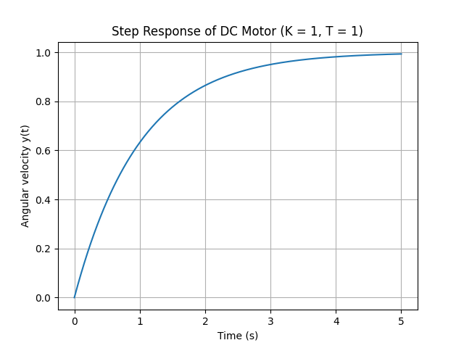
Figure 1. DC motor output response for K = 1 and T = 1
Figure 1 is the DC motor output response with the K = 1 and T = 1. The curve shows a standard first-order response where the angular velocity increases smoothly from zero and approaches the steady-state condition. The response has no oscillation, and the angular velocity reaches approximately 65% of its final value in 1 s.
Figure 2 illustrates the step responses when the gain $K$is fixed and the time constant $T$is varied. In this case, all response curves converge to the same steady-state value because the gain $K$remains constant. However, the speed of the response changes significantly with different values of $T$. Smaller values of $T$result in faster rises times and quicker convergence to the steady-state value, while larger values of $T$produce slower responses. This demonstrates that the time constant $T$controls the dynamic speed of the system without affecting the final angular velocity.
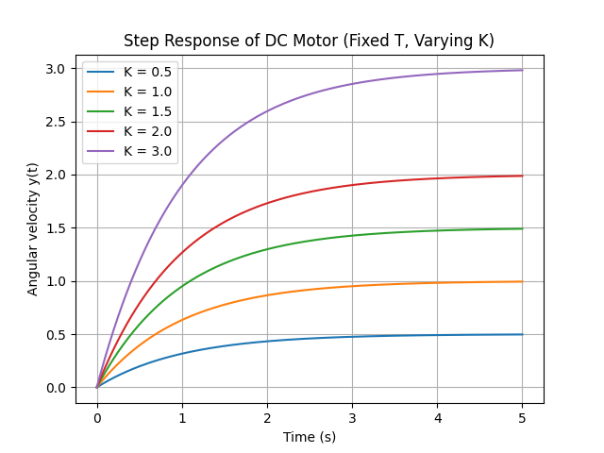
Figure 2. DC motor output response for Fixed T and Varying K
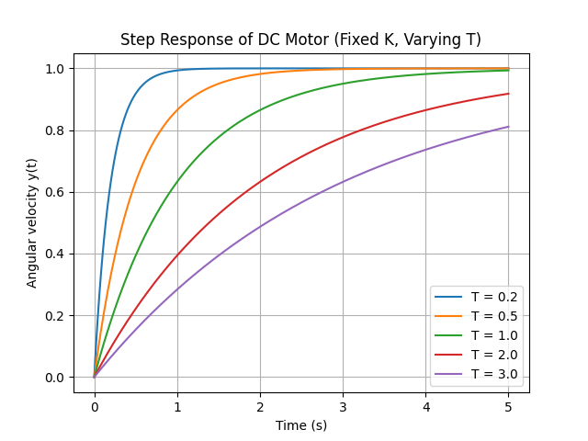
Figure 3. DC motor output response for Fixed K and Varying T
Figure 3 presents the step responses when the time constant $T$is fixed and the gain $K$is varied. In this case, all responses exhibit the same rise speed because the time constant remains unchanged. However, the steady-state value of the angular velocity differs for each curve and increases proportionally with $K$. This shows that the gain $K$determines the magnitude of the steady-state response, while it does not influence the response speed. From this graph, it can be concluded that the parameters $K$and $T$independently control the steady-state and transient characteristics of the DC motor system.
The parameter $K$in the transfer function $G(s)=\frac{K}{1+Ts}$represents the steady-state gain of the DC motor system. It determines the final angular velocity reached by the motor when a constant voltage input is applied. For a unit step input, the steady-state value of the output is equal to $K$, meaning that a larger value of $K$results in a higher final rotational speed. Physically, $K$is influenced by the motor torque constant, the back electromotive force constant, the electrical resistance, and the mechanical friction of the motor. Therefore, $K$reflects the efficiency of the motor in converting electrical energy into mechanical motion and controls the magnitude of the steady-state response.
The parameter $T$ is the time constant of the DC motor system and characterizes the speed of the transient response. It indicates how quickly the angular velocity increases from zero to its steady-state value after a voltage is applied. A smaller value of $T$corresponds to a faster response, while a larger value of $T$results in a slower rise in output. For a unit-step input, the angular velocity reaches approximately 63.2% of its final value at time $t=T$, which provides a clear physical interpretation of the time constant. The value of $T$depends mainly on the moment of inertia of the motor and the damping effects in the system, and it governs the dynamic behavior of the motor without affecting the steady-state value.
Appendix:
Python script for the evaluation of y(t) with K = 1 and T = 1.
import numpy as np
import matplotlib.pyplot as plt

# Time axis
t = np.linspace(0, 5, 500)

# Parameters
K = 1.0
T = 1.0
# Unit step response
y = K * (1 - np.exp(-t / T))
# Plot
plt.figure()
plt.plot(t, y)
plt.xlabel("Time (s)")
plt.ylabel("Angular velocity y(t)")
plt.title("Step Response of DC Motor (K = 1, T = 1)")
plt.grid()
plt.show()

THU TA ZAW
2415121095

